**Batch: C5-3 Roll No.: 54**

**Experiment / assignment / tutorial No. 5**

**Grade: AA / AB / BB / BC / CC / CD /DD**

**Signature of the Staff In-charge with date**

|  |
| --- |
| **TITLE:** Write a program to demonstrate lambda, map, and filter functions in Python  **AIM**: 1) Write a Python program that uses lambda with filter() to select even numbers and map() to square them, displaying the original, filtered, and squared lists.  2) Write a Python program that generates a list of Pythagorean triplets (a, b, c) from a given list of integers, using lambda, filter(), and map(). The program should filter out invalid triplets and display valid ones.  **OUTCOME:** Students will be able to  **CO1:** Formulate a problem statement and develop the logic (algorithm/flowchart) for its solution.  **CO3:** Use different Decision-Making statements and Functions in Python. |

**______________________________________________________________________**

**Resource Needed: Python IDE**

**______________________________________________________________________**

**Books/ Journals/ Websites referred:**

1. Reema Thareja, *Python Programming: Using Problem-Solving Approach*, Oxford University Press, First Edition 2017, India
2. Sheetal Taneja and Naveen Kumar, *Python Programming: A modular Approach*, Pearson India, Second Edition 2018, India
3. https://www.geeksforgeeks.org/python-strings/?ref=lbp

**______________________________________________________________________**

**Theory:**

**Lambda function:**

* A lambda function is a small anonymous function.
* A lambda function can take any number of arguments but have only one expression.
* Syntax

lambda *arguments*: *expression*

**map() function** returns a map object(which is an iterator) of the results after applying the given function to each item of a given iterable (list, tuple, etc.)

***Syntax*** *: map(fun, iter)*

***Parameters:***

* ***fun:*** *It is a function to which a map passes each element of a given iterable.*
* ***iter:*** *It is iterable which is to be mapped.*

**The filter() function** returns an iterator where the items are filtered through a function to test whether the item is accepted.

Syntax:

filter(*function*, *iterable*)

|  |  |
| --- | --- |
| *function* | A Function to be run for each item in the iterable |
| *iterable* | The iterable to be filtered |

**Problem Definition:**

1.In the below table, the input variable, Python code, and output column is given. You have to complete a blank cell in every row.

|  |  |
| --- | --- |
| Python Code | Output |
| x = lambda a : a + 10 print(x(5)) |  |
| x = lambda a, b : a * b print(x(5, 6)) |  |
| def myfunc(n):   return lambda a : a * n  mydoubler = myfunc(2)  print(mydoubler(11)) |  |
| **def** addition(n):  **return** n + n  numbers = (1, 2, 3, 4)  result = map(addition, numbers)  print(list(result)) |  |
| numbers = [1, 2, 3, 4, 5, 6, 7, 8, 9, 10]  evens = list(filter(lambda x: x % 2 == 0, numbers))  print(evens) |  |
| square = lambda x: x ** 2  result = square(4)  print(result) |  |
| chars = ['a', 'b', 'e', 'i', 'o', 'u', 'z']  vowels = list(filter(lambda x: x in 'aeiou', chars))  print(vowels) |  |

**2) Write a Python program that uses lambda with filter() to select even numbers and map() to square them, displaying the original, filtered, and squared lists.**

**3) Write a Python program that generates a list of Pythagorean triplets (a, b, c) from a given list of integers, using lambda, filter(), and map().**

**The program should filter out invalid triplets and display valid ones.**

**Implementation details:**

2)

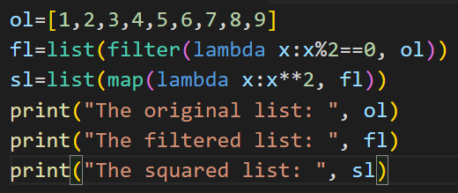

3)

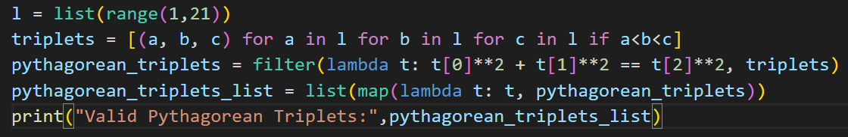

**Output(s):**

2)

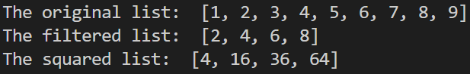

3)



**Conclusion:** In this experiment, I got hands-on practice performing lambda, filter and map functions in various combinations.

**Post Lab Descriptive Questions :**

**Q1. Explain the following built-in functions of python:**

**1.abs()**

**2.max()**

**3.exec()**

**4.range()**

**Sol:**

1. **abs()** : Used toreturn the **absolute value** of a number (int or float).

It can also be used to return the magnitude of any complex number.

Eg., Input: 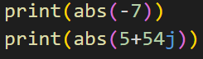 Output: 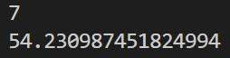

1. **max() :** Used to return the **largest** of the input values.or the item with the   
    highest value in an iterable. For string inputs, the string which comes last in lexicographical (or dictionary) order is returned.

Eg., Input: 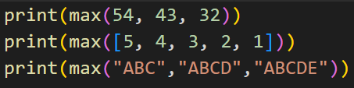 Output: 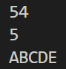

1. **exec()** : Used to **execute** the Python code dynamically, which can also be a   
    string (or a code object).

Eg., Input: 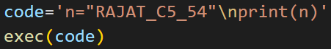 Output: 

1. **range()** : Used to **generate** a **sequence** of **numbers**. It can take three arguments (start, stop, step). The start is inclusive, while stop is exclusive, and step is used to skip certain no.of elements.

Eg., Input: 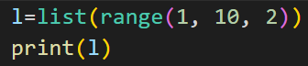 Output: 

**Q2. Explain the difference between user-defined function and built-in function.**

**Sol:**

|  |  |
| --- | --- |
| **User-Defined Functions** | **Built-In Functions** |
| The functions that are **created** **by** the **programmer**. i.e., the functions you create yourself to solve a problem. | The functions that are **predefined** **by** the **programming language**. i.e., the functions that come ready-made with Python. |
| **Defined** using the **def** **keyword**. | **Predefined** in the language, therefore **no need to define**. |
| These are **available** **only** within the code **where** the function is **defined**. | These are **available in any** pythonprogram**,** thus **globally accessible**. |
| Fully controlled by the programmer thus making it **customizable**. | Predefined by the developers thus making it **un-customizable**. |
| **Eg.** | **Eg.** |